Please submit a solution for the following problem statement. Whatever database you are comfortable with, submit a solution based on that. SQL queries for SQL database, mongo script for Mongo db. If you are comfortable with Excel then share the steps one by one that you would do for the solution.

Problem statement -
There is a table, named app_launches, with two columns (in case of mongo, collection of objects with two keys) -
1. user_id (integer) - This column has ids of users of Krishi Network android application. Each user has a unique id. Example - 121
2. timestamp (datetime field) - This is the timestamp when the application is launched by a user. Example - 22/09/2021 17:15:41

Whenever any user launches the application, a new row is added to the table. In the new row, user id will be assigned based on who launched the application and timestamp will be the date and time when the app was launched by that user. A user may launch the app 10 times a day then there will be 10 rows in the table for the user.
This table already holds 50 millions rows for 10 million users.

Table preview for reference –

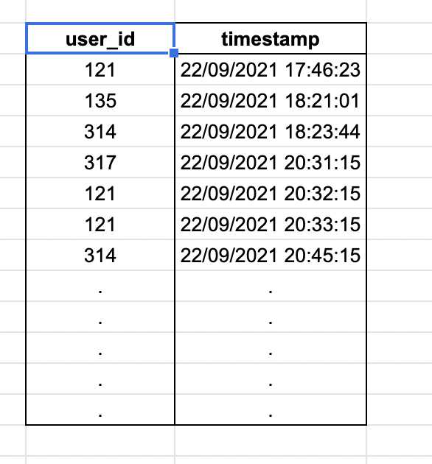

Question 1 - Find out count of daily active users against each data in July, 2021. Output should have two columns - date & count of active users on the date. Any user who launched the application is considered active for that day.

Question 2 - What percent of total users use the application on their day 2? Day 2 here means a day after a user installs the application. For example if you installed the application on 5th September then 5th September is considered day 1 for you. 6th September is considered day 2 for you. So each user will have his own day 1, day 2 and so on, based on what date he installed the application. You need to write query(s) for calculating - What percent of total users use the application on their day 2?

